Biometric Auth REST Service

# Background

Biometric Auth REST service can be used to authenticate an Individual using below types of Biometrics -

1. Fingerprint
2. Iris
3. Face

## Target users -

TSP can use Auth service to authenticate an Individual by using one or more types of authentication supported by MOSIP and retrieve Auth details as a response.

## Key Functional Requirements -

* TSP can authenticate an Individual using one or more authentication types
* TSP will send Individual’s UIN/VID to enable authentication of Individual
* TSP will send muaCode and msaCode to authenticate and authorize a TSP to authenticate an Individual
* Check Individual’s UIN/VID for authenticity and validity
* Validate biometric details of the Individual against the one stored in database
* Inform authentication status (success/failure) to the Individual in the form of message and/or email

## Key Non-Functional Requirements –

* Log :
  + Log each stage of authentication process
  + Log all the exceptions along with error code and short error message
  + As a security measure, Individual’s UIN or PI/PA should not be logged
* Audit :
  + Audit all transaction details during authentication process in database
  + Individual’s UIN should not be audited
  + Audit any invalid UIN or VID incidents
* Exception :
  + Any failure in authentication/authorization of TSP and validation of UIN and VID needs to be handled with appropriate error code and message in Auth response
  + Any error in Individual authentication also should be handled with appropriate error code and message in Auth Response
* Security
* Auth details of an individual is a sensitive information, hence should be encrypted before sending to TSP
* Auth Request contains sensitive identity information of an Individual. This information should be encrypted by TSP before sending to IDA. On receiving this request, TSP should decrypt **identity** element before validating Individual’s details for authentication purpose

# Solution

Auth REST service addresses the above requirements as explained below.

1. TSP needs to construct a **POST** request with below details and send to Request URL **identity/auth**

[ID Authentication API - Sample Request](<https://github.com/mosip/mosip/wiki/ID-Authentication-APIs#sample-request>)

1. Authenticate and Authorize TSP <<TBD>>
2. Validate “reqTime” for incoming Auth Requests for valid format and timestamp < 24 hours (configurable value) from current time
3. Integrate with Kernel UIN Validator and VID Validator to check UIN/VID for validity. Validate UIN/VID for authenticity in AuthDB
4. Once the above validations are successful, Auth request is then validated based on biometric - Fingerprint/IRIS/Face - authentications present in input request. For these types of authentications, below are types of inputs supported –
   1. Fingerprint – Image and Minutiae based
   2. Iris – Image based
   3. Face – Image based
5. Retrieve Identity details of the Individual based on UIN from ID Repository
6. Retrieve mode of communication with Individual using admin config to send authentication success/failure information
7. When the Individual is successfully authenticated based on one or more of the above authentication types, a sms/email notification is sent to them using Kernel’s SmsNotifier and EmailNotifier to their stored phone/email respectively.
8. Respond to TSP with below success Auth response –

[ID Authentication API - Sample Response] <https://github.com/mosip/mosip/wiki/ID-Authentication-APIs#sample-response>

## Class Diagram:

The below class diagram shows relationship between all the classes which are required for authentication service.

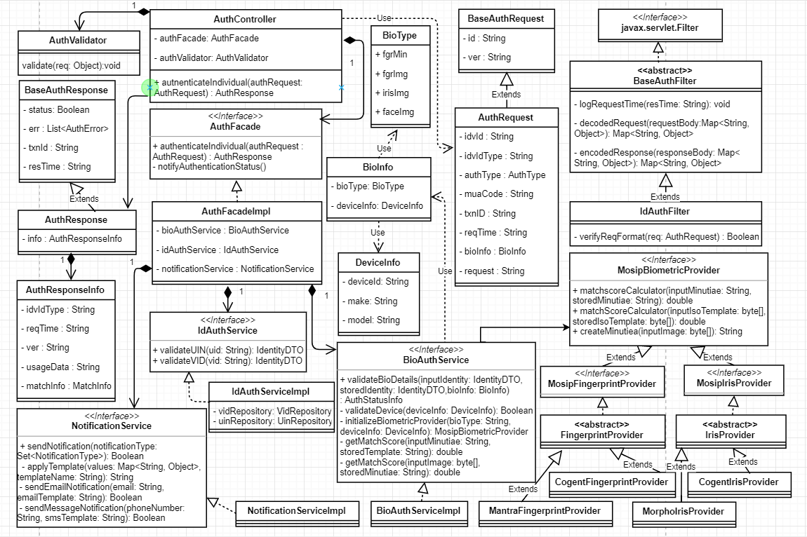

## Sequence Diagram:

